*These instructions are for accessions of electronic records received on media (e.g. compact discs, DVDs, floppy disks, hard drives, USB keys, etc.).*

1. Identify digital records media and set aside for accessioning (Accessioning staff)

* **MSSA:** Ensure there is an accession record that already exists in the Archivists’ Toolkit. If there is not an accession record already, follow the accessioning procedures to create one: <https://collaborate.library.yale.edu/mssa/ad/Wiki%20Pages/Home.aspx>
* Obtain the materials from the accession in question and take the media to the workstation in SML B50.
* **MSSA:** Place the media on the appropriate shelf in accession number order, and add or change location [criteria when appropriate] to “SML – B50 – Workstation MSSA61.”

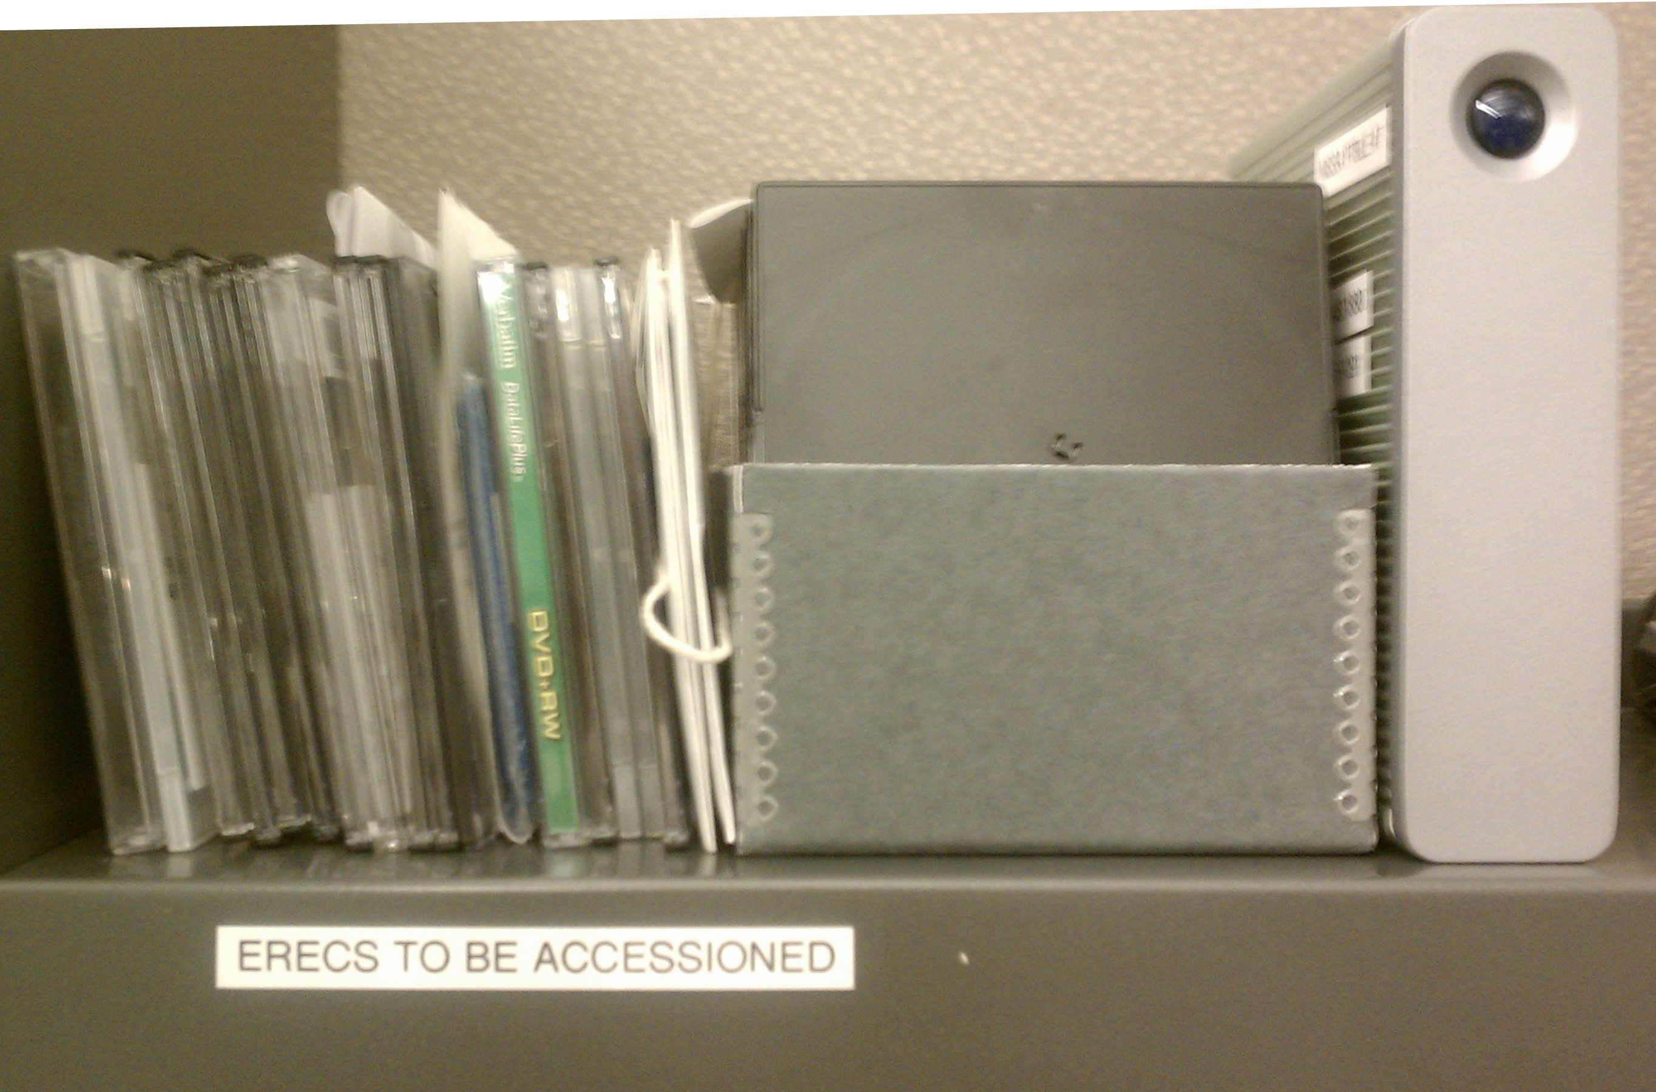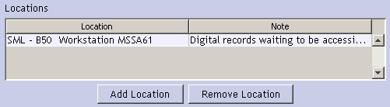

* Number each piece of media according to the following scheme,  
  <accession number>.<incremental 4-digit zero-padded number>  
    
  For example, for accession 2010-A-063, which contains two floppy disks, should be numbered as 2010-A-063.0001 and 2010-A-063.0002.  
    
  **NOTE:** Depending on the format of the media, you may not be able to mark the piece of media with the number physically. Floppy disks with paper labels can be marked in pencil. External hard drives can have an additional label affixed to the outside. If you are working with a DVD or CD, you can write on empty case.

**Complete steps 2-3 once for each accession.**

1. Open the Electronic Records on Media Accessioning Log list (Digital Archivist)

* MSSA: <https://collaborate.library.yale.edu/mssa/ad/Lists/ERecs%20on%20Media/AllItems.aspx>
* BRBL:

1. Prepare directories and documentation for imaging (Digital Archivist)

* Create a new directory under \\mssa94\d$\RR_Staging\MSSA\Images or \\mssa94\d$\RR_Staging\BRBL\Images with the accession number. For example, for the accession MSSA 2010-M-025, create \\mssa94\d$\RR_Staging\MSSA\Images\2010-M-025.
* Create a new folder in the Media Accessioning Log with the accession number.

**Repeat steps 4-10 for each piece of media.**

1. Create an entry in the media log for the piece of media. Fill out the following before imaging:

* Media number (see step 1 above)
* Media format (select from dropdown list, or add custom choice)
* Media density (floppies only; select from dropdown list)
* Interface (hard drives or other mass storage only)
* Label text (direct transcription of any writing on label or case of media)
* Manufacturer
* Serial number (for hard drives only)
* Examiner (fill out as you; either lastname, firstname or yale\netid)

1. If appropriate, connect medium to write blocker.
2. Load the appropriate imaging software:

* For hard drives, drives that connect over USB (Flash drives, Zip disks), and optical media (CDs and DVDs), use FTK Imager.[1]
* For floppies, use Imagetool3 for any floppies on MSSA63, FC5025 for 5.25” disks on [**workstation**], or FTK Imager if the floppy drive connects directly over USB.
* **FTK Imager only:** Make sure software is set to provide hash values on completion of imaging.

1. Tell imaging software to create new image.

* **FTK Imager only:** Use “logical drive” as the source option (not “physical drive”).
* Regardless of image software, the file format will usually be a “raw” (or “dd”) image. Optical media will be imaged in a format that includes an ISO file and a CUE file.
* Specify the image destination using the following scheme: \\mssa94\d$\RR_Staging\<repository>\Images\<accessionnum>\<medianum>.<format>
* For example, for 2011-M-005.0001 (a CD), create image in the following location: \\mssa94\d$\RR_Staging\MSSA\Images\2011-M-005\2011-M-005.0001.iso

1. Start the imaging process and monitor the success.
2. Save logs into the directory containing the image file. FTK Imager will automatically save log files into this directory. You will have to tell ImgBurn to save the logs here explicitly.
3. Once the imaging process ends, fill out the following fields in the media log:

* Imaging Successful? (Yes/Yes, with errors/No choice; examine logs/dialog boxes to determine)
* Image filename (see step 7)
* File system (if identifiable from logs or within FTK image; if unsure and it’s a CD, choose ISO9660; if unsure and it’s a DVD, choose UDF)
* Image format (choose from dropdown)
* Imaging software (choose from dropdown)
* Image fixity function (only FTK Imager provides MD5 currently; may need to use other software)
* Image fixity value (copy/paste)
* Notes (any additional notes, particularly if imaging was unsuccessful or had errors)

Once this information is added, save the entry in the media log.

1. Move the directory for the accession number from the Images folder to the Needs_Metadata folder.

**Repeat steps 12-15 for each subdirectory containing disk images. (Mark M. for now)**

1. Run fiwalk to extract metadata for each disk image, and send the output to a file named <medianumber>.xml in the same directory as the disk image. For example, for the image file 2011-A-005.0001.iso, run the following command on mssaserver04:

fiwalk -fxc ~/fiwalk-dgi/ficonfig.txt 2011-A-005.0001.iso > 2011-A-005.0001.xml

The -f flag runs the Unix file command on each file within the image. The -x flag tells fiwalk to output the data as XML. The -c flag tells fiwalk to run two plugins referenced in the given configuration file (virus scan and PRONOM format identification).

1. Ensure the log file, if present, for each disk image is named as <medianumber>.txt.
2. Update the Metadata Extracted? value in the media log to show completion and save.
3. Move the directory for the accession number from Needs_Metadata to Needs_Packaging.
4. Open the Bagger GUI application and select “Create New Bag.” In the Profile dropdown, select “YUL_DISKIMG_ACCN_SIP_0.2”.
5. In the Payload pane, click the green plus icon to add files to the bag. Add the directory for the accession from the Needs_Packaging directory.
6. In the Bag-Info pane, complete the following fields. **NOTE:** All fields with a red “R” are mandatory.

* External-Identifier: [4-letter repository code]-[accession number] (e.g. mssa-2010-M-025)
* YUL-Accession-Number: [accession number]
* External-Description: [Optional but recommended note about contents, source, or title]
* YUL-Forms-Part-Of: [collection call number with repository code prefix; can use YFAD ID]
* YUL-Source-Department: [dropdown list]

For example, for accession 2010-M-025, which is part of MS 1475, insert the following:

* External-Identifier: mssa-2010-M-025
* YUL-Accession-Number: 2010-M-025
* YUL-Forms-Part-Of: mssa.ms.1475
* YUL-Source-Department: Manuscripts and Archives
* External-Description: Images of unsold paintings. Forms part of Arnold Rosin papers.

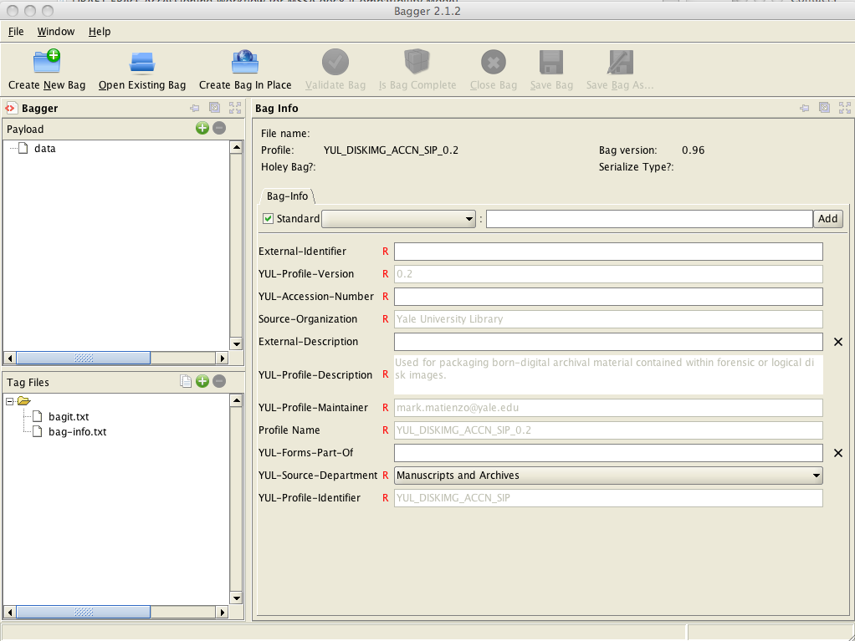

1. Click the Save Bag As… button.
2. Make sure “Holey Bag?” is unchecked; “Serialize Type” is “None”; and “Generate Tag Manifest“ and “Generate Payload Manifest” are both checked with both algorithms set to MD5.
3. Find the Ready_For_Transfer directory, and in the File Name field, enter the value recorded in the “External-Identifier” field.
4. **MSSA:** Update the accession record as follows:

* Remove location for SML – B50 – Workstation MSSA61.
* Add location for ERECS ­ ­mssa61 with note “ERecs awaiting A&D”.
* Add location for SML – B51-A – Shelf 58 with note “ERecs media”.
* Add external document with title “E-Recs Accessioning Log” with HREF being the link to  
   the folder in SharePoint.
* Make sure “Computer Files” box is checked in the user defined fields.
* Add extent in MB (megabytes) in User Defined Fields.
* If processing status is “Processed,” change to “ERecs Need A&D”.

1. Shelve successfully imaged media on B51-A range 58. This is arranged by accession number.
2. Copy transfer BagIt directory in c:\RR_Staging\MSSA\Ready_To_Transfer to Isilon staging area or Rescue Repository.
3. When successfully transferred, update media log with transfer date and save. Also update accession record and change location ERECS mssa61 to either ERECS Isilon or ERECS Rescue Repository as appropriate, retaining note regarding records needing arrangement and description.

1. Note: previous accessions of optical media used ImgBurn. FTK Imager is now the preferred option.